Year 7 Science

**Chemistry 1 Test**

**SECTION 1: MULTIPLE CHOICE** (1 mark each)

Circle your answer on the multiple choice answer sheet.

1. A **physical change** is
   1. when a new substance is formed.
   2. one that can easily be reversed.
   3. when bubbles, smell or a colour change are released.
   4. also called a chemical reaction.
2. Which of the following is **not** a sign that a chemical change has taken place?
   1. melting or evaporating
   2. a colour change
   3. bubbles or smell
   4. a change in temperature
3. Which of these is a good example of a **physical change**?
   1. melting ice
   2. cooking an egg
   3. reacting bicarb and vinegar
   4. burning a candle
4. Which of the following pictures shows **decantation**?

a) 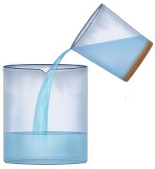b) 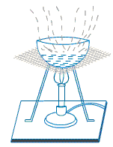

c) 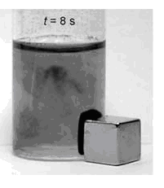 d) 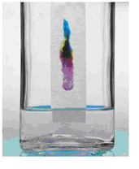

1. The separation techniques that relies on one substance being **more soluble** than another is
   1. decantation.
   2. magnetic separation.
   3. filtration.
   4. evaporation and crystallisation.
2. The diagram below shows

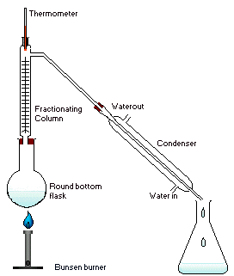

* 1. decantation.
  2. chromatography.
  3. filtration.
  4. distillation.

1. Distillation is **not** useful for
   1. purifying water.
   2. making distilled water.
   3. making essential oils or alcoholic liquors.
   4. extracting pure salt from sea water.
2. The best type of separation technique to separate **iron filings from sand** would be
   1. decantation.
   2. filtration.
   3. magnetic separation.
   4. distillation.
3. **Paper chromatography** is good for separating
   1. mixtures of food colours.
   2. mixtures of perfumes or flavourings.
   3. sugar from sand.
   4. gases.
4. Which of these will **not** make a sugar cube dissolve faster?
   1. heating
   2. adding more sugar
   3. stirring
   4. crushing the sugar cube

**SECTION 2: WRITTEN**

**Write your answers in the spaces on the answer sheet provided.**

1. Draw a labelled scientific diagram of the apparatus for **filtration**. (6)
2. Explain **step by step** how you would separate a mixture of sand, sugar and iron filings, so that you could recover each part of the mixture in a relatively pure form. (4)

________________________________________________________________________________________________________________________________________________________________________________________________________________________________________________________________________________________________________________________________________________________________________________________________________________________________________________________________________________________________________________________________________________________________

1. Explain what the term “**saturated solution**” means. (2)

________________________________________________________________________________________________________________________________________________________________________________________________________________________________________________________________________________________________________________________________________________________________________________________________________________________________________________________________________________________________________________________________________________________________

1. Starting with muddy sea water, which **separation techniques** you would use to end up with
2. clean sea water.

____________________________________________________________________________________________________________________________________________________________________________________________________________________________________________________________

1. dry salt.

____________________________________________________________________________________________________________________________________________________________________________________________________________________________________________________________

1. pure water.

____________________________________________________________________________________________________________________________________________________________________________________________________________________________________________________________ (3)

**END OF TEST (OUT OF 25 MARKS)**